Musical Arts International, Inc
Presents
Crossroads of Classical and Jazz

Jeffrey Chappell, pianist

Sunday, May 5th, 2013 at 3PM

Reception Follows
MusicalArtsInternational.org

Calvary Lutheran Church – 9545 Georgia Ave. Silver Spring, MD 20910

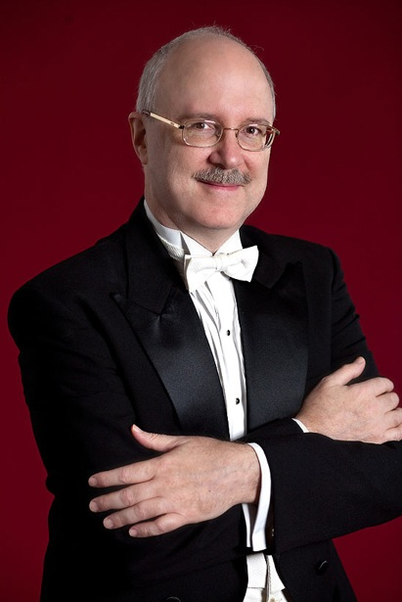
JEFFREY CHAPPELL has performed throughout the United States in recitals and chamber music and has been a soloist with major symphony orchestras including the Philadelphia, St. Louis, Pittsburgh, Houston, Oakland, and Indianapolis Symphony Orchestras. Frequent appearances with the Baltimore Symphony include concerts at Carnegie Hall and Wolf Trap Park, and a substitution for Claudio Arrau on four hours’ notice playing the Brahms Second Concerto. He was a recipient of the Solo Recitalist Fellowship from the National Endowment for the Arts. He has concertized in Europe, Asia, and Latin America, and appeared at summer festivals including Marlboro and the La Gesse Festival. Many of his performances have been heard on radio broadcasts nationwide. His solo piano composition “American Sonata” won the Keyboard Magazine Soundpage Competition, and “Shadowdance” was commissioned by the Mid-Atlantic Chamber Orchestra with a grant from the Meet The Composer Foundation. Mr. Chappell was a scholarship student of Leon Fleisher at the Peabody Conservatory and of Rudolf Serkin and Eleanor Sokoloff at the Curtis Institute. Early studies were in St. Louis, Missouri, as the protégé of Jane Allen. He is Director of Jazz Studies at Goucher College in Baltimore, Maryland, and is on the faculty of the Levine School of Music in Washington, D.C. He was a contributing editor for Piano & Keyboard Magazine.
For reservations &tickets, 4 or2 -concert discounts for next season, please call 301-933-3715.
Tickets: Adult $20, Student/Senior $15

Performing
Ravel - Jeux Deau, Chopin- Andante Spianato,
Waltz in E flat Major, Bartok - Romanian Folk Dances,
Jazz Tunes, Jay McShann - Hootie Blues,
Jeffrey Chappell - Tenderly, Tomorrow, Jazz Sonata.

10% discount at
Good Fortune Restaurant (301-929-8818) Seven Seas Restaurant (301-770-5020) and the on the concert day
with your ticket

2013-2014 season
Oct 5th 2013 - Sunrise String Quartet; Dec 8th 2013 - Brett Miller Brass Quintet
March 15th 2014 - Michael Adcock - Jose R. Santana Piano Duo;
May 25th 2014 - Qing Li, Violin

MAI is supported in part by funding from the Maryland State Arts Council.
Musical Arts International, Inc. is a 501(c)(3) non-profit organization

