Musical Arts International, Inc Presents
Marcolivia Violin/Viola Duo
Marc Ramirez, violin ~ Olivia Hajioff, violin & viola
Saturday, March 16th, 2013 at 8PM
Reception To Follow
MusicalArtsInternational.org
Latvian Lutheran Church – 400 Hurley Ave. Rockville, MD 20850

Marcolivia is an award-winning violin and violin/viola duo who performs music from all styles and periods, including Folk Music and Salon/Virtuoso works. Concerts of Baroque music and works by 20th century composers are also offered, as well as humorous and dazzling "showpieces" for family concerts. They have adjudicated and given masterclasses for events organized by the Washington Performing Arts Society. In 2011, Marcolivia was invited to be the founding members of a new resident chamber ensemble, the Phillips Camerata, based at the Phillips Collection and the National Gallery in Washington DC.

Marcolivia performed at Chamber Music America's 25th Anniversary Concert in NYC, alongside groups such as the Juilliard Quartet. The duo is on the roster of the Millenium Stage at the Kennedy Center and the Virginia Commission For The Arts Touring Roster.

Olivia Hajioff and Marc Ramirez enjoy successful individual solo and chamber music careers. Ms. Hajioff, a Fulbright scholar, received a BBC Young Musician of the Year Award and was also a prize winner in the European Violin competition. In her native England she has performed chamber music at the Dartington International Festival with David Owen Norris and Stephen Bishop Kovacevich. She has concertized throughout Europe and the U.S. notably in London’s Wigmore Hall, the South Bank, Cheltenham Festival, Paderewski Hall in Switzerland, and the Kennedy Center. Arnold Steinhardt (Guarneri Quartet) described her as a “compelling performer”.

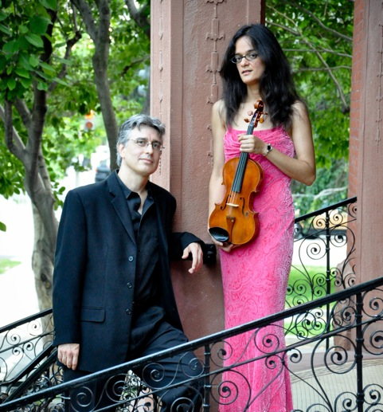
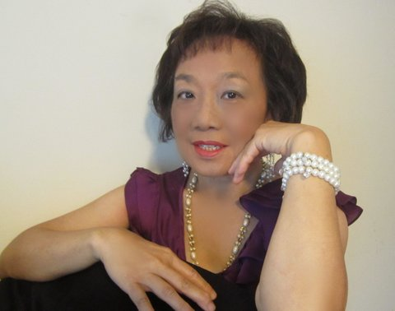
Mr. Ramirez has concertized throughout Europe and North America, performing at such halls as the Tretyakov Museum in Moscow, Carnegie Recital Hall, and the Kennedy Center Terrace Theater. His recitals have been broadcast on many radio stations, including those in New York, Chicago and Los Angeles. Among his awards are First Prizes in the Henryk Szeryng Competition, the Parisot-Friedman International Competition, and the Cavallaro International Competition for a two-year Fellowship to Yale University. From 1983-1986, he was invited by Henryk Szeryng to study and tour with him, visiting many European cities. The Washington Post has described his playing as “intensely beautiful”.

Li-Ly Chang is a pianist, composer, and the Director of International Young Artist Piano Competition. “Ms Chang performs sensitively with expert technique, emotional expressiveness and a firm sense of partnership” -- Washington Post. “Her artistic ability and dedication to giving a crowd pleasing performance made a very memorable day for us” – Washington Summer Music Festival. “Her performance reflected her superb sensitivity and creativity both as a pianist and as a composer” -- The State Department State of the Arts Cultural Series.

Performing
Martinu “Sonatina for Two Violins and Piano”, Bartok selections from “44 Duos for Two Violins”,
Mozart “Best -Loved Arias from Magic Flute”, Beethoven “Gassenhauer Trio”, op.11

10% discount at Seven Seas Restaurant (301-770-5020) and the
Good Fortune Restaurant (301-929-8818) on the concert day with your ticket

Upcoming Concerts:
Jeffrey Chappell, piano, May 5th, Sunday 3pm in Silver Spring (Crossroads of Classical and Jazz)

MAI is supported in part by funding from the Maryland State Arts Council.
Musical Arts International, Inc. is a 501(c)(3) non-profit organization
For reservations and tickets, including 2 concert discounts, please call 301-933-3715.
Tickets: Adult $20, Student/Senior $15

